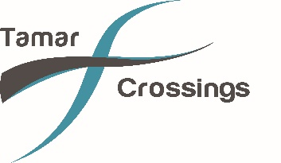
Tamar Tower Tours

Please read the following information to ensure the tour will be suitable for you or a member of your party/family.

THE THINGS YOU NEED TO KNOW BEFORE YOUR VISIT

- Your wellbeing is important:

You must be reasonably fit and meet our Fitness Requirements and Health and Safety Exceptions.

We will ask you to complete a Tamar Tour Declaration Form on the day. You will need to be able to climb ladders independently maintaining three points of contact at all times.

Please be honest about your health and speak to your guide if you have any concerns – all discussions are confidential.

- What will you be required to do?

The tour involves:

- Walk through narrow doors and access ways (600mm/2ft wide)

- Ascend and descend steep and vertical ladders (6 x ladders with a total climb of over 33m /100ft)

- Walk along a suspended walkway at the top of the towers

- Walk on a see through floor above the traffic lanes

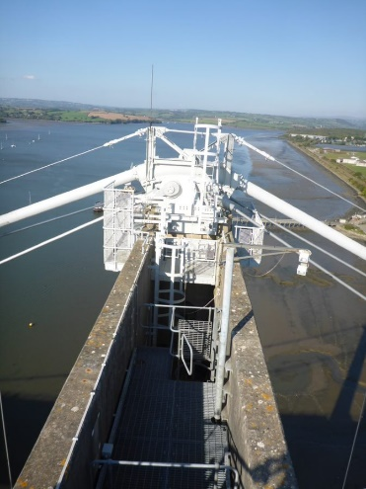
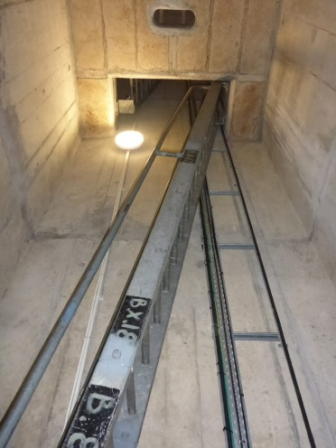
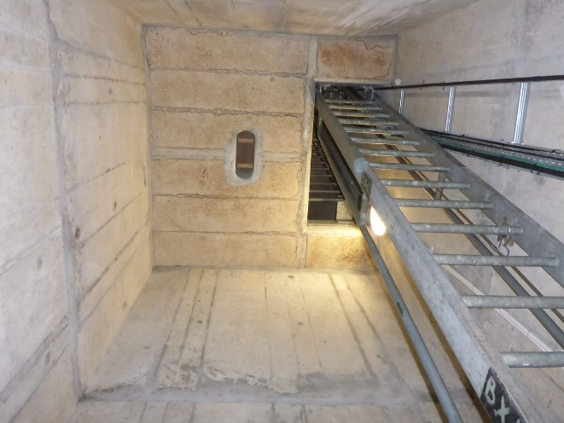

You must follow your guide’s instructions at ALL times and tell them immediately if you feel uncomfortable.

There are no lifts or toilet facilities in the Towers.

- How should you prepare for the tour?

Ensure you are well fed and hydrated on the day of your tour – the experience normally lasts around 45mins.

You must not be under the influence of alcohol or any other substances which impairs your physical or mental judgement.

- What should you wear?

You will need to wear:

  - sensible, layered clothing in which you move freely (not shorts)

  - comfortable, enclosed rubberised shoes such as running, sport or hiking shoes

We will provide a hard hat, safety harness, gloves and a hi-viz jacket.

We don’t want anything to drop from height so you will asked to remove any loose items, coins and other personal belongings (they can be securely stored in the office).

For safety and security reasons, all mobile phones and cameras will need to be secured in a lanyard or holder.

- Weather

Tours operate in most weather conditions but may be cancelled during extreme weather events such as high winds or electrical storms.

FITNESS REQUIREMENTS – CAN YOU CLIMB THE TOWER?

You need to have a general level of health and fitness and be able to climb ladders independently.

On the day of your tour, you will need to complete the Tamar Tour Declaration Form – please be honest about your health so we can ensure your safety. There are also some health and safety exceptions – please read below.

In general, you should not have any aliment or condition that prevents you from safely climbing ladders, accessing confined spaces or high areas.

The following considerations could impact your ability to climb safely so we would strongly advise you consult your GP if you have any of the following conditions: -

- If you are over 75 years of age
- If you are under 24 weeks pregnant
- Severe vertigo or claustrophobia
- Heart disease or any cardiac condition that may require immediate medical condition
- Respiratory conditions or sever shortness of breath
- Neck, back or other muscular/skeletal conditions or sprains/strains
- Surgery from which you still recovering
- Epilepsy
- Blood thinning medication

Essential medication like inhalers can be taken up with you as long as you can safety secure it in a zipped/secure pocket
Our staff and volunteers are not medically qualified to assess the capacity or health of a participant to undertake activities. It remains your responsibility to undertake such an assessment prior to participation.

Fear of heights and confined spaces

Our tour takes you the top of bridge and it’s perfectly natural to be a little apprehensive and excited! It’s perfectly natural for people who have had no previous vertigo or claustrophobia reactions to be unsure how they may react – after all you probably don’t do this every day. Rest assured our guide will be on hand at all times during your visit. Don’t be embarrassed to speak to them as soon as you feel uncomfortable or have any questions.

HEALTH AND SAFETY EXCEPTIONS

We endeavor to be as inclusive as possible and help everyone take part, however there are some things that will prevent you from participating, including:
- if you’re more than 24 weeks pregnant
- If you’re under the influence of alcohol or other substances
- if you have a pre-existing condition which prevents you from taking part
- limited limb function, loss or limb difference preventing a minimum three-point contact whilst climbing vertical ladders
- serious sight and/or hearing impairment
- broken bones
- a fit or seizure in the last six months
- under 18 years of age
- under 1.2 metres tall
If in doubt or are concerned about whether you can take part, please speak to our team as soon as you can and before the climb starts.
Please be aware we reserve the right to decline participation or change or modify exceptions at any time.

